**Tableau Assignment 2**

1. What is Tableau Data Engine?
   1. Hyper powers the Data Engine in Tableau Server, Tableau Desktop, Tableau Online, and Tableau Public. The Data Engine is used when creating, refreshing or querying extracts. It is also used for cross-database joins to support federated data sources with multiple connections. Process.
2. How to create a calculated field in Tableau?
   1. In Tableau, select Analysis > Create Calculated Field.
   2. In the Calculation Editor that opens, do the following:
      1. Enter a name for the calculated field.
      2. Enter a formula
3. Can you tell the differences between TreeMap and Heat Map?
   1. Geographical attributes can be used in both maps
   2. These are help us to view both simple & complex data
   3. Two-dimensional representation with the help of color is known as Heatmap
   4. If you have a large amount of highly structured data, then the best option for visualization is a Treemap
   5. Treemap split up into rectangles, sized and ordered according to the quantitative measures
4. What are the components of a dashboard?
   1. Horizontal, Vertical & Image are the components of dashboard
   2. 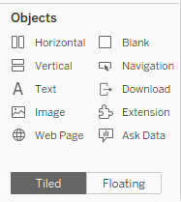
5. Based on the given data, analyse and answer the following questions

* 1. How much sales have come from customers from the previous in the current year in terms of Sales Value?

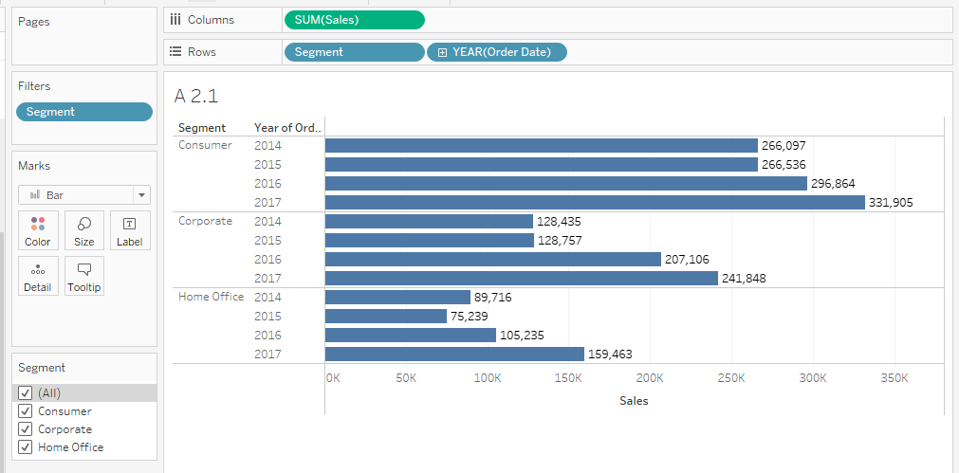

* 1. How much sales have come from customers from the previous in the current year in terms of Sales Percentage?

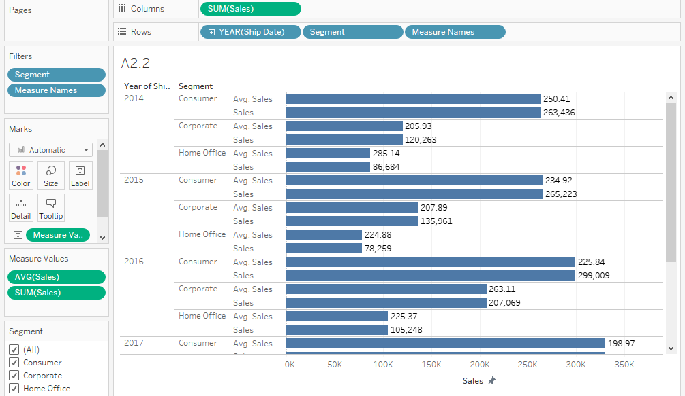

* 1. Find the orders placed by each customer.

